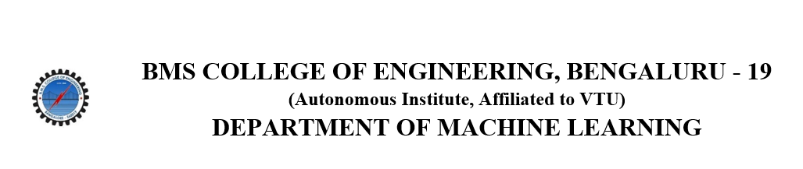
ACTIVITY REPORT
On

EMINENT SPEAKER PROGRAM

- Name of the club : BMSCE ACM Student Chapter
- Name of the Activity: Eminent Speaker Program
- Objectives: The objective of this Eminent Speaker Talk was to dive into the challenges of transforming theoretical cryptographic security into real-world applications and to learn how to build systems that withstand modern cyber threats.

- Date, Time Venue of the Activity:
SPEAKER | Mr. Sikhar Patranabis, Staff Research Scientist, IBM Research India
TOPIC | CryptoVerse: Securing The Digital World
DATE/DAY | Tuesday, 8th April 2025
TIME | 6:00 PM - 7:30 PM.
VENUE | Online

- Name and details of collaborating agency (if it is collaborative/joint activity): None

- Brief Summary Of The Event:
Mr. Sikhar Patranabis shared insights on the journey of cryptography from theoretical foundations to practical implementations, highlighting challenges in bridging provable security with real-world deployment.
The talk explored the fascinating field of cryptography as pursued by IBM Research India, where around 200 researchers were engaged in pioneering work on threat management, cloud infrastructure, secure data and AI handling, as well as decentralized trust.
The central theme was Zero Knowledge Proofs (ZKPs)—a groundbreaking cryptographic protocol that allowed one party (the prover) to convince another (the verifier) that a certain statement was true, without disclosing any additional information beyond the truth of the statement itself. ZKPs were built on four core principles: completeness (if the statement was true, an honest verifier would be convinced), soundness (a dishonest provider could not convince the verifier of a false statement), zero knowledge (no knowledge beyond the assertion was revealed), and succinctness (the proofs were short and efficiently verifiable).
These principles were brought to life through intuitive examples, such as the color blindness test involving red and green balls and the Ali Baba cave scenario, both of which demonstrated how knowledge could be proven without exposure.
The talk further delved into ZKPs of knowledge, such as demonstrating possession of a secret key (e.g., discrete logarithm problems) without revealing it, and highlighted the importance of arithmetic circuits for representing complex relations in general-purpose ZKP systems. These circuits formed the foundation of modern ZKP protocols, including SNARKs (Succinct Non-Interactive Arguments of Knowledge), which offered compact proof sizes and low verification costs.
The talk also connected these cryptographic advances to real-world applications, particularly in blockchain technology, where zk-rollups were used to improve scalability. By offloading computation and enabling succinct verification of state updates, zk-rollups helped reduce gas fees, increase transaction throughput, and maintain the integrity of blockchain systems.
Overall, the talk emphasized how cryptographic innovation was not only theoretically rich but also practically vital for the future of secure computing and scalable decentralized systems.
7. Outcomes: Participants gained valuable insights into how theoretical cryptographic concepts are applied to real-world systems. The talk enhanced their understanding of advanced security protocols and encouraged exploration of research opportunities in cryptography and blockchain scalability.
8. Number of participants:
Number of Attendees | 30

9. Two or three relevant Photographs of the activity: (Geo-tagged photos are preferable)

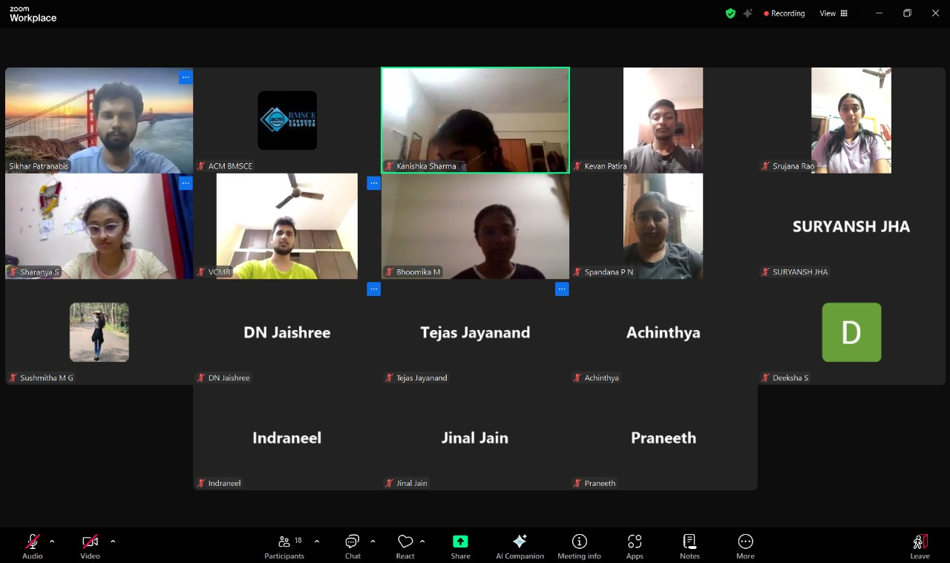

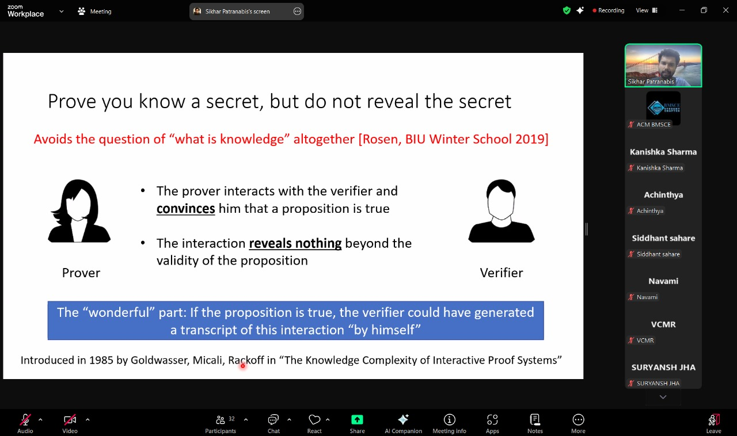

10. Supporting Documents
a) Circulars/Brochures

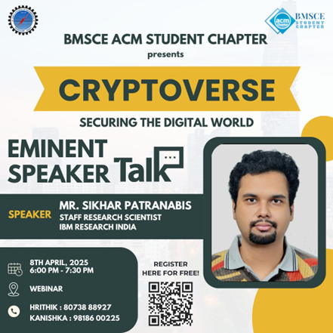

b.)Attendance

Name | USN | College e-mail ID | Branch
Shilpa Kumari | 1BF24AI154 | shilpakumari.ai24@bmsce.ac.in | Machine Learning (AIML)
Srujana | 1BM22CD062 | srujana.cd22@bmsce.ac.in | Computer Science and Engineering(DS)
Kevan Patira | 1BF24CS136 | kevanpatira.cs24@bmsce.ac.in | Computer Science and Engineering
Tejas Jayanand | 1BM23CB056 | tejasjayanand.bs23@bmsce.ac.in | Computer Science and Business Systems
Deeksha S | 1BM23CH010 | deekshas.ch23@bmsce.ac.in | Chemical Engineering
Sushmitha M G | 1WN24CS295 | sushmithamg.cs24@bmsce.ac.in | Computer Science and Engineering
SURYANSH JHA | 1BF24CS308 | suryanshjha.cs24@bmsce.ac.in | Computer Science and Engineering
Kashvi Agarwal | 1BM23CS142 | kashviagarwal.cs23@bmsce.ac.in | Computer Science and +Engineering
Spandana P.N | 1BM23EE058 | spandanapn.ee23@bmsce.ac.in | Electrical and Electronics Engineering
Harshith Praveen | 1BF24AI073 | harshithpraveen.ai24@bmsce.ac.in | Machine Learning (AIML)
Bhoomika. M | 1BM23CS068 | bhoomikam.cs23@bmsce.ac.in | Computer Science and Engineering
Bhoomika B G | 1BM23CS067 | bhoomikabg.cs23@bmsce.ac.in | Computer Science and Engineering
Disha Baid | 1WN24CS096 | dishabaid.cs24@bmsce.ac.in | Computer Science and Engineering
Jinal Jain | 1WA24CS138 | jinaljain.cs24@bmsce.ac.in | Computer Science and Engineering

